EM425 Assignment #5

Problem Statements

1. (Based on 6.19) Create a user-defined function for linear regression. The signature should be [a,Er] = LinReg(x,y). In addition to determining the constants  and  for a linear least-squares fit to the data, the function should also calculate the squared residual:



The input arguments  and are vectors with the values of the data points. Use the function to find the coefficients for a linear least square fit to the following data and find the error.

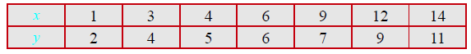

2. (Based on 6.40) The following are measurements of the rate coefficient,  for the reaction  at different temperatures 

Use the method of least squares to best fit a function of the form  to the data. Determine the constants C, b and D by curve fitting a linear combination of the functions ,  and  to the given data. Usually, the rate coefficient is expressed in the form of an Arrhenius equation  where A and b are constants, R=8.314 J/mole/K is the universal gas constant, and  is the activation energy for the reaction. Having determined C, b, and D, deduce the values of A (m3/s) and Ea (J/mole) in the Arrhenius expression.

3. (Based on 6.4) The following data is given:

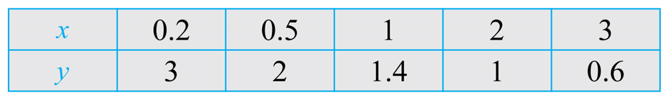

By hand, determine the coefficients  and  in the function  that best fit the data using linear least-squares fit.

m = ___________, b = _____________

4. (Based on 6.27) The resistance  of a tungsten wire as a function of temperature can be modeled with the equation  where  is the resistance corresponding to temperature , and  is the temperature coefficient of resistance. Determine  and  such that the equation will best fit the data. Use  = 20oC.

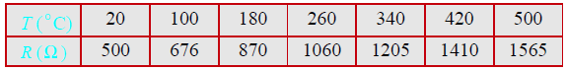

5. (Based on 6.30) In a uniaxial tension test, a dog-bone-shaped specimen is pulled in a machine. During the test, the force applied to the specimen,  and the length of a gage section,  are measured. The true stress,  and the true strain, are defined by:



Where  and  are the initial cross-sectional area and gage length, respectively. The true stress-strain curve in the region beyond the yield stress is often modeled by:



The following are values of  and measured in an experiment. Determine the values of the coefficients  and  that best fit the data. The initial cross-sectional area and gage length are  m2, and  m. [**Note:** be careful with units.]



***Numerical Answers***

1. 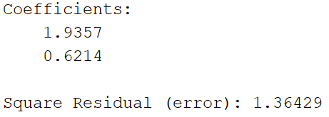
2. My advice is for the third function just use 1/T and not -1/T. Let the sign be provided by your curve fit function. Answer: c1 = -52.4427, c2 = 2.1216, c3 = -3815.342 (check your result with a plot of the data and the curve fit)
3. m = 0.45, b = 0.24
4. 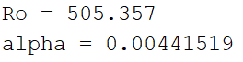
5. 